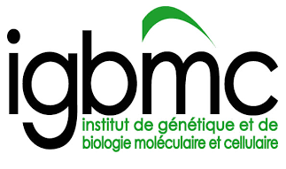
New tools in biological studies

PROJECT: Specific enzymes or their substrates are frequently shared by different metabolic pathways which is critical for a balanced production of different types of bioactive molecules. We propose to use click chemistry, which we recently validated for in vivo use (Ursuegui et al., NatComm 2017) and other new chemical tools for non-hypothesis driven identification of specific and shared metabolic pathways, relevant enzymes, receptors and ultimate targets of action. This multidisciplinary project emerging from close collaboration with specialists in chemistry will benefit from a large library of novel purpose-developed reagents. In vivo and in vitro functional studies will be carried out using mouse genetic models dedicated for metabolic analyses and relevant for studies into neurodegenerative diseases.
The project will be carried out at IGBMC and Mouse Clinical Institute (Strasbourg-Illkirch), international research institutes located in the heart of dynamic research region at crossroads of France, Germany and Switzerland. It will benefit from such location and state-of-the-art infrastructure and expertise in animal behavior and pharmacology, molecular, genomic and bioinformatics analyses.
We are looking for highly motivated post-doctoral fellow with strong background in biochemistry and/or enzymology and excellent expertise in cell cultures, molecular biology and imaging (life imaging in vitro or in vivo or super-resolution microscopy is encouraged). Candidate must have at least one first author publication. The ability to work in an English speaking team and good communication skills are required. The ideal candidate should be able to bring personal input to the challenging multidisciplinary project, write scientific papers, contribute to preparation of research grants and participate in animating team’s life.
Applicants should submit their complete application file (CV, motivation letter, publication list and contact to at least two reference scientists in one PDF file) by email.
Contact information:
Wojciech Krezel (Research Director, INSERM)
IGBMC, 1, rue L.Fries, 67404 Illkirch (CU Strasbourg), France
email: krezel@igbmc.fr

