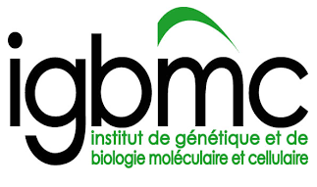
New targets and pathways in neuroprotection – relevance for treatment of basal ganglia disorders.
PROJECT: The project aims at validating new molecular determinants of striatal dysfunction and neurodegeneration. It will employ known and new mouse models relevant to Huntington and Parkinson diseases. It will benefit from (and should extend) a large amount of genomic (RNAseq, ChIPseq, proteomics) and molecular data relevant to the project which are available in the team. Such data point to neuroprotective activities of selected nuclear receptors and metabolic pathways. Thus testing neuroprotective activities of synthetic or newly discovered endogenous ligands of such receptors is envisaged and should highlight new pharmacological or nutritional strategies in prevention or treatment of neurodegenerative diseases.
The project will be carried out at IGBMC and Mouse Clinical Institute (Strasbourg-Illkirch), international research institutes located in the heart of dynamic research region at crossroads of France, Germany and Switzerland. It will benefit from such location and state-of-the-art infrastructure and expertise in animal behavior and pharmacology, molecular, genomic and bioinformatics analyses.
We are looking for highly motivated post-doctoral fellow who has a solid background and research experience in mitochondrial biology or neuron-glia communication. Technical expertise in molecular biology, primary cell cultures, imaging will be required whereas experience in genomic, bioinformatics analyses is strongly encouraged. Candidate must have at least one first author publication. The candidate should be able to bring personal input to the challenging multidisciplinary project, write scientific papers, contribute to preparation of research grants and participate in animating team’s life.
Applicants should submit their complete application file (CV, motivation letter, publication list and contact to at least two reference scientists in one PDF file) by email.
Contact information:
Dr Wojciech Krezel (Research Director at INSERM)
IGBMC, 1, rue L.Fries, 67404 Illkirch (CU Strasbourg), France
email: krezel@igbmc.fr

